Andrew Costley
Centerspread
Sandy (The Big Bad Killer)
Families Mourn for Loved Ones Lost to Sandy
As the month of November closes, America mourns for its citizens lost on the east coast at the end of October to the brutal flooding and wrath of Hurricane Sandy.
So far, 113 people have lost their lives to this brutal storm. The hardest hit state was New York, with fatalities of 48 people. Other states on the East Coast also lost people to the storm: New Jersey, 24, Pennsylvania, 14, Maryland, 11, West Virginia, 7, Connecticut, 4, North Carolina, 2, Virginia, 2, and New Hampshire, 1.
Many of the fatalities were caused by falling trees. Fierce rain softened the soil around big trees and almost 80 mph winds eventually caused the trees to fall on houses and, sadly, un-suspecting people. Some places, including West Virginia, lost citizens to heavy snow gathering on roofs that eventually caved in on homes. Many people in New York drowned after finding themselves trapped in their basement during the storm, while fallen power lines in flooded streets electrocuted and killed anyone who put a foot in the water. One elderly woman died after her respirator lost power during the storm.
As America slowly recovers from this deadly hurricane, many on the East Coast hope their loved ones are found alive. However, many are grateful that so many people were spared.

http://www.thebohmerian.com/wp-content/uploads/2012/10/fallen-tree-in-pawling-ny-after-2012-hurricane-sandy1.jpg
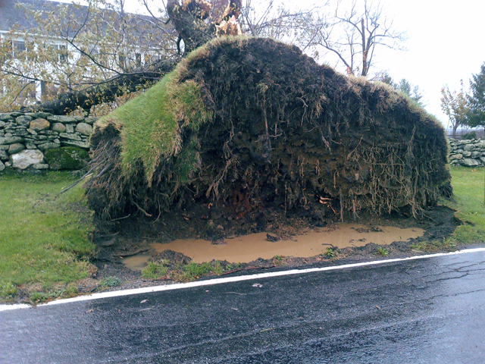
Courtesy of www.thebohmerian.com

