Andrew Costley
December 11, 2012
Journalism, Period 5
Pg. Centerspread
The World Celebrates its Holidays
A World of Celebrations
Holidays
December is truly the holiday season! Though known for Christmas, there are many other holidays this month that are still important in many peoples’ hearts.
One of the first big holidays this month was Bodhi Day, which was celebrated on December 8. It is one of the biggest holidays in Buddhism. It was said that on this day, the Buddha, Siddhartha Gautama, became enlightened and reached a state known as Nirvana, where the brain becomes free of ignorance, greed, hatred, and other afflictive states. Buddhists celebrate this day with a celebratory meal and increased meditation and reading hours.
Another holiday, lasting for a total of 8 days, is Hanukkah. Starting on this year on December 8th and ending December 16th, this Jewish holiday celebrates the successful Maccabee Revolt of 165 BCE against the Syrian king, Antiochus III. The Hebrews organized a festival and rededication of the Second Temple. However, the rededication was hopeless as they only found one jar of oil, which would only burn for one day. Miraculously, the oil burned until more oil could be made, which was eight days later. Followers of Judaism now celebrate this event with 8 nights of gifts, meals, games, and lighting a candle every night on a menorah.
A final large holiday celebrated this December is Kwanzaa. Kwanzaa starts on the 26th and ends on January 1st. It is a week long holiday celebrating the West African Diaspora and connections between families and their African roots and community. It is celebrated with feasts, gifts, ritual music and dancing, and the lighting of a kinari, a menorah shaped holder containing seven candles, every night. Each candle in the kinari represents a different principle in African Culture.

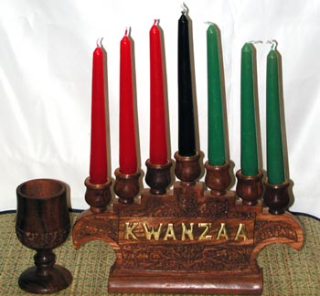
http://www.wilsdom.com/store/media/kwanzaa-kinara6003p.jpg
For an extra, larger picture
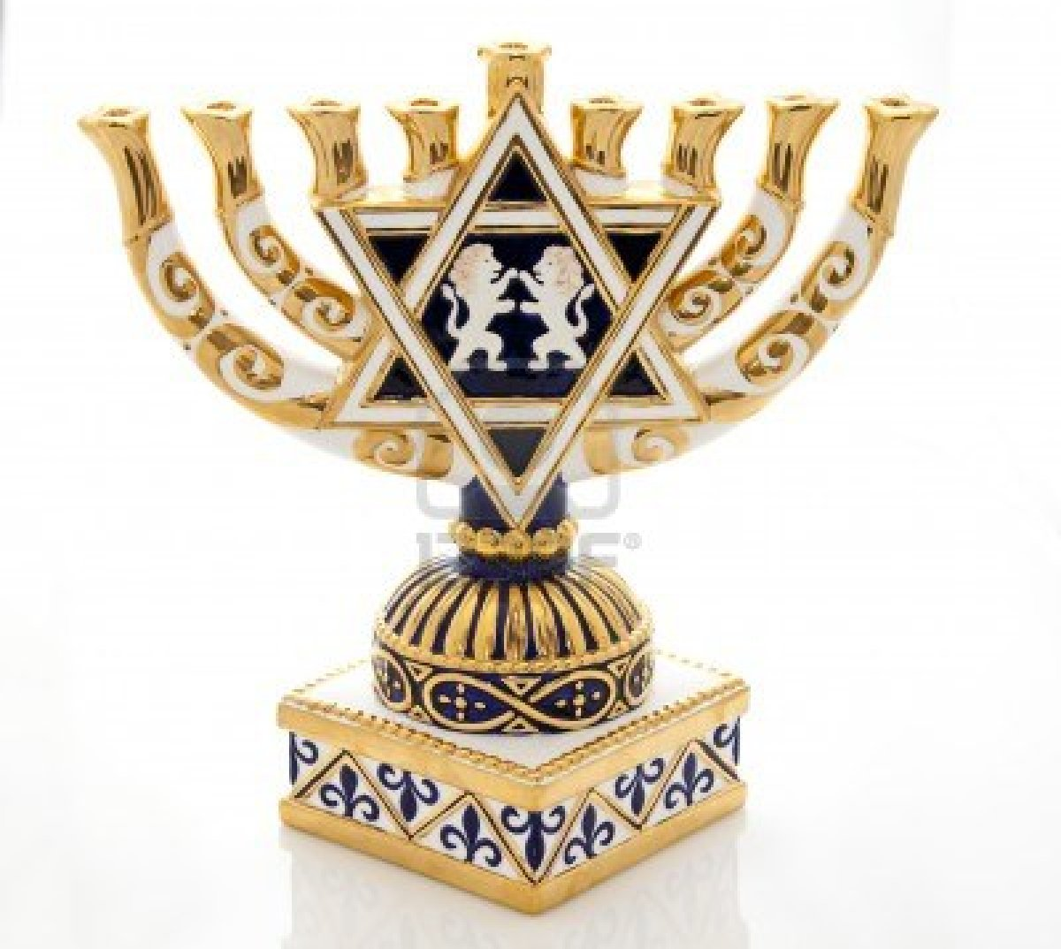
http://us.123rf.com/400wm/400/400/mishella/mishella1210/mishella121000924/15578734-hanukkah-menorah.jpg

