Andrew Costley
March 7, 2013
Journalism, Period 5
News
Pope Benedict XVI Steps Down
Holy See Says Goodbye to their Leader
New Pope

For the first time in 700 years, a pope has stepped down from his spot as head of the Catholic Church. This time, it was Pope Benedict XVI on February 28, 2013 at 8 pm.
At 85, the Pope is the first to end his papacy before death. He claimed his papacy was too tiring and stressful, and not for an old man like him to run the church.
Every Cardinal from around the world gathered to discuss and vote for a new Pope in the Sistine Chapel, their choice most likely a current Cardinal.
Times have changed for the church. Secularism has turned many away from the church. Europe, once the church’s strongest area of influence, has faded from the Vatican’s grasp. Their strongest followers now reside in Latin America, Africa, and Asia. Meanwhile, the church is losing their younger generation. Many Americans think a younger Pope would connect more to today’s people.
When white smoke rises out of the Sistine Chapel’s chimney, it signifies a new pope has been chosen. After days of waiting, the world saw white smoke rise around 7:00 pm on March 13, 2013. It was revealed the archbishop of Buenos Aires, Jorge Mario Bergoglio, was elected as the new Pope. He will now be Pope Francis I, after church patron Saint Francis of Assisi.
Though Pope Benedict XVI has retired from his position, he will still be referred to as “his holiness” and will spend the rest of his life under the care of the church at multiple papal retreats.
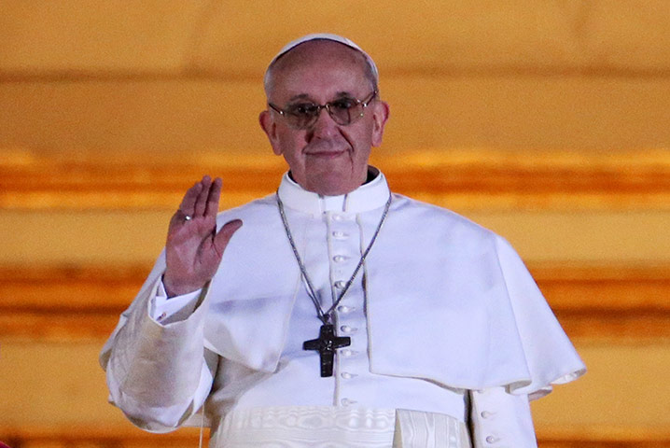

Pope Francis I welcomes the crowd of people gathered outside of the Sistine Chapel.
http://static.guim.co.uk/sys-images/Guardian/Pix/pictures/2013/3/13/1363203356761/Pope-Francis-I-appears-on-006.jpg

